**Bacteria Visualizer User Manual**

This manual is for anyone wishing to use this application. The manual goes through how to run the application.

1. Running the Application
   1. Accessing the Application
   2. Exploring Data Correlations
   3. Exploring Filtering Options
2. Restrictions
3. Errors
   1. Test Site Error
   2. End Date less than Begin Date Error
   3. Time-Slice Error
   4. Species Selection Error

For information regarding how the files interact see **README**, which describes the file structure of the application.

For information regarding how the functions work see the file with the function in question. The comments in the file describe the functions use.

**Running the Application**

**Accessing the Application**

After you start the server; you should see a line that looks something similar to:

`Listening on [http://127.0.0.1:6050`](http://127.0.0.1:6050%60)

Copy the given url into your browser. When you do that you should see:

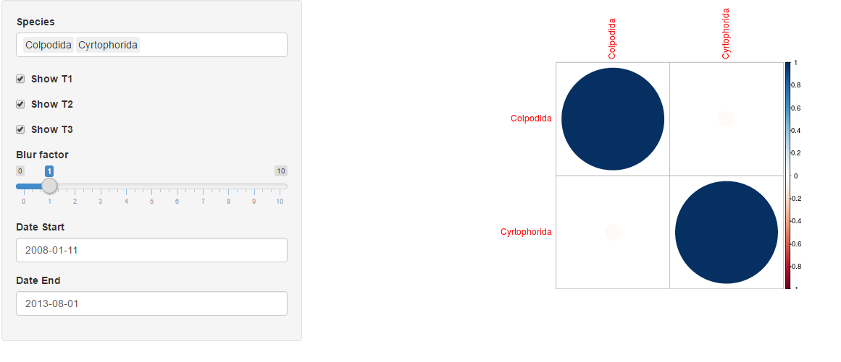

Startup Image

If you do not see this when you copy the url to your browser, please go back to the start of **Accessing the Application.**

**Exploring Data Correlations**

There are quite a few things you can do to find and explore correlations in your data. The first thing you’ll want to do is add species. Initially, only **“Colpodida”** and **“Cyrtophorida”** are selected. Click on the “Species” input and then click on an item in the dropdown to add it into the correlation matrix. Adding each species will add a row and column to the matrix.

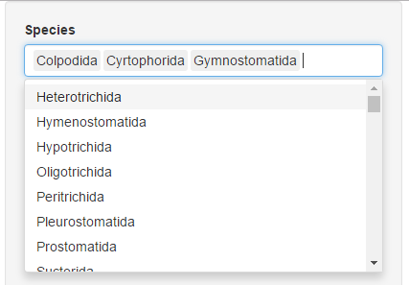

Species Dropdown Menu

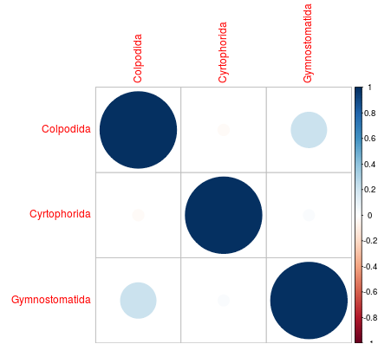

Updated Correlation Matrix

But what do the circles represent? Each grid cell represents a correlation between species. The correlation coefficient is represented by the circle size. (INFO ON CORRELATION COEFFICENT). The regression slope is represented by the circle color. The color legend can be found on the right-side of the graph.

How does this apply to bacteria? You want to be able to see relationships in the relative abundance of arisa and ciliates. You want to see species that change in conjunction with other species. If you add **“Colpodida”** and **“X300”** to the grid, you’ll see a large light blue circle.

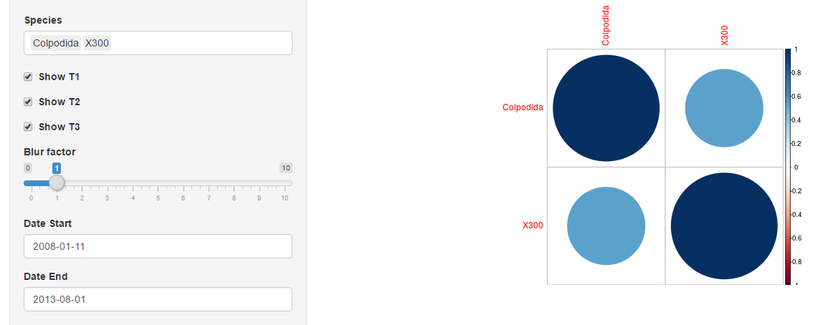

Correlation Example

This means that when Colpodida changes, X300 tends to change as well and vice-versa.

**Blurring**

JOEL DO THIS

**Exploring Filtering Options**

You can also gain insights into your data by modifying the filtering options. The “Show T1/T2/T3” checkboxes will enable/disable observations from their respective sources.

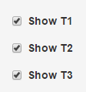

Location Checkboxes

This can be useful to find differences in each location.

The “Blur factor” is useful for finding correlations between species that may not happen simultaneously. For example, an increase in a predator population may cause a decrease in a prey population, but only a few days later. The blur functionality will let you see correlations between these types of relationships. Setting the blur factor to zero turns blurring off.

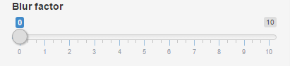

Setting blur factor to zero

For any other value, each row will be distributed among consecutive rows, using the Gaussian function for weight (<https://en.wikipedia.org/wiki/Gaussian_function>). The blur factor is the standard deviation of the function. For example, a blur factor of 2 will distribute each row among the 16 or so surrounding rows, distributed by a Gaussian function with a standard deviation of 2.

The start/end date are used to decide the beginning and end of the time slice. With values outside of that range being dropped.

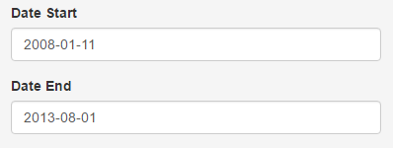

Date Selectors

If you wish to change from the default values, click on the text box and either rewrite in the form **YYYY-MM-DD**, or select from the calendar menu provided.

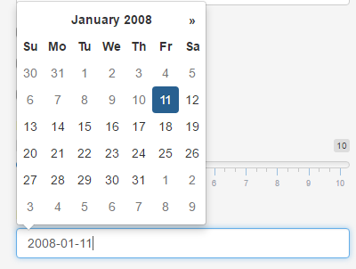

Calendar Menu

**Important Restrictions**

Although you can upload any file for datasets, our program can only work with datasets that ae saved as CSV’s.

To convert a .xls to a .csv follow these steps:

1. Open the .xls in excel

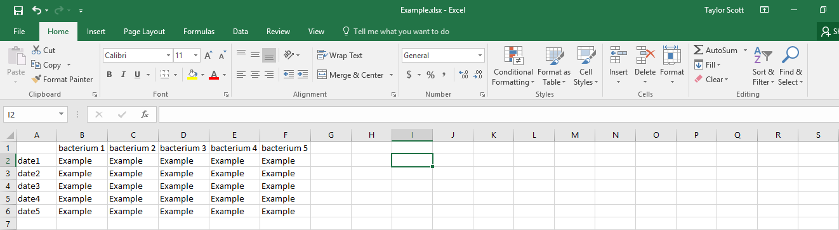

1. Choose save as and get to this screen

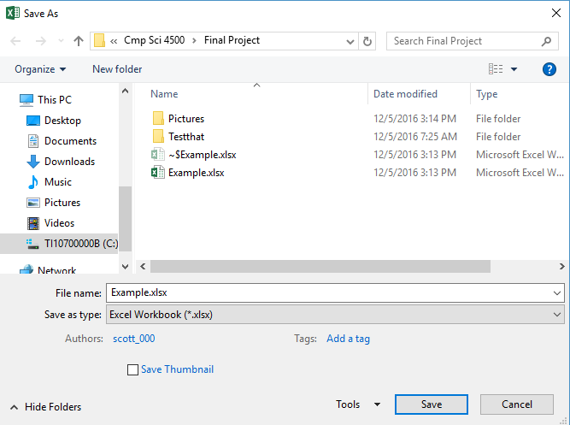

1. Choose the CSV option

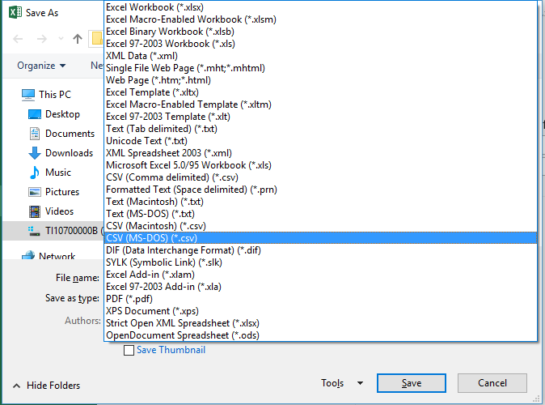

1. Click “Yes” on the pop up box and you’ll have a csv file

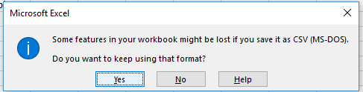

**--- All CSV’s must only include one tab ---**

**Errors**

When you have the application running multiple errors can arise.

1. No test-site selected error



This error can be resolved by checking the boxes correlating to their respective test site.

1. End date smaller than begin date



This error can be resolved by changing the maximum date to a date larger than the minimum date.

1. Time-slice to small



This error can be resolved by choosing a minimum and maximum date that are further apart.

1. Species selection to small



This error can be resolved by selecting at least 2 species from the species selection menu.